Be Cool-Car Pool
A project for 159356



18 September 2008
By: Arlo, Ben, James, Jordan, Parul & Sam

Table of Contents

1. Introduction 2
2. Project Methodology 2
3. Project Plan
3.1 Scope 3
3.2 Gantt chart 4
4. Design Documentation
4.1 Domain Model 6
4.2 Use Case Diagram 7
4.3 Use Cases 8
5. Risk Mitigation Monitoring and Management 14
6. Software Quality Assurance
6.1 Unit testing 16
6.2 Usability Testing 17
6.3 Compatibility Testing 17
6.4 Integration Testing 17
6.5 Process Monitoring 17
6.6 JDepend 18

1. Introduction

Car Pool is an online system being developed to encourage and manage car pooling in Palmerston North. Users register for the service and can use existing Open ID compliant user accounts for this purpose. Users will be able to offer rides and accept offers. When an offer is made or accepted the ride is added as an event to the user’s Google Calendar. This calendar can then send the user automated emails reminding them of their ride. Each user has a social score which is helpful for drivers and riders to identify who contributes to the car pooling community and find out if someone is good or bad rider or driver.

2. Project Methodology

For our project we decided to combine the principles of the Agile methodology with the process framework of Rational Unified Process (RUP). The RUP process framework was applied to the first and second iteration we produced and will also be applied for the final iteration. A single iteration is expected to result in a working part of the system being built and multiple iterations (in our case three) are expected to result in the fully integrated complete product.

RUP has the following four phases: Inception, Elaboration, Construction and Transition. Inception and Elaboration involve identifying the various actors with which the system will interact and defining the nature of this interaction. To this end we develop design documentation that helps us define the scope of our project. We do this using Unified Modeling Language (UML) for the most part. Risk assessment is done in the form of Risk Mitigation Monitoring and Management (RMMM). A project plan, defined using Gantt chart, along with the scope for iterations, is also expected from the aforementioned phases. These are ‘live’ documents that are expected to evolve and change over the course of various iterations. The Construction phase involves the actual building of the components along with integration and testing. And finally the Transition stage involves ironing out any tiny problems and putting in features that were postponed. As stated before all iterations will have all four of these phases.

RUP recommends modeling visually which is why UML is used to create the design documentation. The modeling is done in a Just in Time (JIT) basis as prescribed by Agile methodologies. This means that the scope of the model is restricted roughly to what is required to be implemented in the near future (e.g. 3-4 weeks). Agile methodologies prescribe avoiding Big Design Upfront (BDUF) because requirements are expected to change over the course of the project anyway! Therefore though we have developed an overall design for a system, this design is subject to change depending on our project’s evolution. The same principle is applied to our project plan. Our Gantt chart focuses on planning in detail for the near future for the most part and we continually reassess and extend the chart depending on how the project proceeds. Agile methodologies also prescribe addressing priority features at a time which is why at the beginning of the project a scope will be identified for each of the three iterations which will define what features will be developed for that iteration. Finally, it is recommended that standard routinies be automated and we do this through ANT scripts.

3. Project Plan

3.1 Project Scope

Below appear the scopes for our first, second and final prototype. These have changed and will continue to change as the project continues depending on how well or bad our progress for a particular iteration is proceeding and the changing priorities of the features expected from our project.

Scope for Prototype One

The aim of the first prototype was to achieve successful integration of calendar, database and user login with the website.
- Users can register for system using Open ID accounts
- Users can log into system successfully
- Users can add a ‘one-off’ ride offer by specifying location from and to, the date and time, and the seats available in text fields.
- The ‘one-off’ offer event gets added to user’s Google Calendar if they have one.
- Users can see a list of all the rides available in the database
- Users can accept a ride.
- The database of users and locations can communicate with the web interface.

Scope for Prototype Two

The aim of the second prototype was to evolve the website into a more user-friendly version with most of the functionality that one would expect from a car pooling site.
- Users can register for the site using a username and password if they do not have an Open ID. Users can log in with this username.
- Users can edit their details.
- When creating a ride offer the users have to select streets from a combo box and specify the house number they are departing from. Users can add any other comments as well.
- When users are accepting a ride offer they are taken to the appropriate ‘accept a ride’ page and they are able to specify the location they would like to be picked up at along with any other comments.
- The Ride page should show the current users in the ride and where they are being picked up from
- Google Maps is integrated with the ride page to illustrate the locations the ride will pass during its travel.
- Users can search for rides.
- Users can see a list of rides they have offered and accepted from their account page.
- Safeguarded registration
- Driver and Rider can talk via Comments on the Ride page

Scope for Prototype Three

The aim of the final prototype is to add all postponed features necessary for the success of the project and achieve maximum security and usability that we can for the site
- Users can withdraw rides and edit ride details. Users can withdraw from rides.
- The user who offered the ride is given the choice of being able to confirm or deny the acceptance after which the ride gets added to the user who accepted the ride’s account
- After acceptance by driver the rider can add the ride to their Google Calendar
- A social scoring system will be implemented
- Users can add and accept regular rides
- The website will follow good HCI principles.
- Ensure all functionality works on the Massey server where the site is hosted
- Any concurrency, Security, Optimization issues will be resolved

Changes made to the Scope since last iteration (Iteration One)

As explained earlier all design and planning documents are subject to change during the course of the project in keeping with the project methodology we prescribe to. This proved really useful as after completing our first iteration we came to the realization that certain features we were planning were either going to be redundant or not useful for our project. The changes we have made to our scope since iteration one will be outlined below with an explanation of why the changes were made:

During Iteration One, in our design documentation and scope we had stated that a user will be able to add ride offers as well as ride requests with our system. Since then we have revised the scope of our project and will now only be offering users the ability to add offers. The group felt that the system we are building relies on certain users being helpful and offering others rides. It does not seem plausible that not only do these users have to offer rides every time they make a trip but they also have to search through the requests page to see if they are going in the same direction as other users and thus try and fulfill their requests. It is up to the users who want to go somewhere to look through the system and see if ride offers they want are available.

Furthermore, the idea of users ticking a checkbox in the Offer A Ride page to specify if there will be a return trip or not has been discarded. Should there be another trip from departure location back to start location this should be treated as a separate offer that the user adds the system. This is because some users may want to be in the ride going one way but not back. If the seats available were to reduce to 0 despite the fact that one person is not going to be taking the ride back then another user who did need the ride back but did not need the ride to the place is disadvantaged. Additionally other users may want to know of the trip back which they wouldn't find out about as that return ride information would only appear as a mention in the original ride page.

Following the recommendation of our clients (the lecturers) we have reduced the scope of our system to only streets within Palmerston North instead of the system being used to organize rides from one city to another. Also the via locations thing is something that will be added by a rider not the driver. Due to this change we have also decided that instead of having the driver specify which locations they will be traveling via we shall now have the rider specify where the driver can pick them up. The driver has the right to decline the acceptance of their offer.

Proposals made for the our project such as users being able to specify more than one date for a ride, ride events being able to be added to any calendar the user wants not just the Google calendar and the users being able to have an RSS feed for rides from and to certain locations that they are interested in are under re-evaluation currently. These are features that will enhance our system however we may not have time to implement them anymore.

3.2 Gantt chart

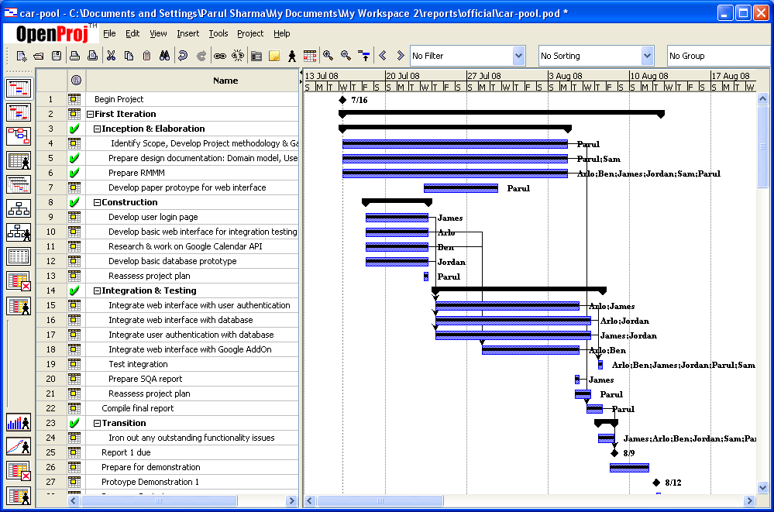
Figure 1: Gantt chart – First Iteration

The Project Gantt chart is continually updated as the project proceeds. The first iteration, displayed in Figure 1, was focused towards gaining an overview of the system that will be developed, creating the most basic features required and ensuring the various components that will make up the system are integrated well together.

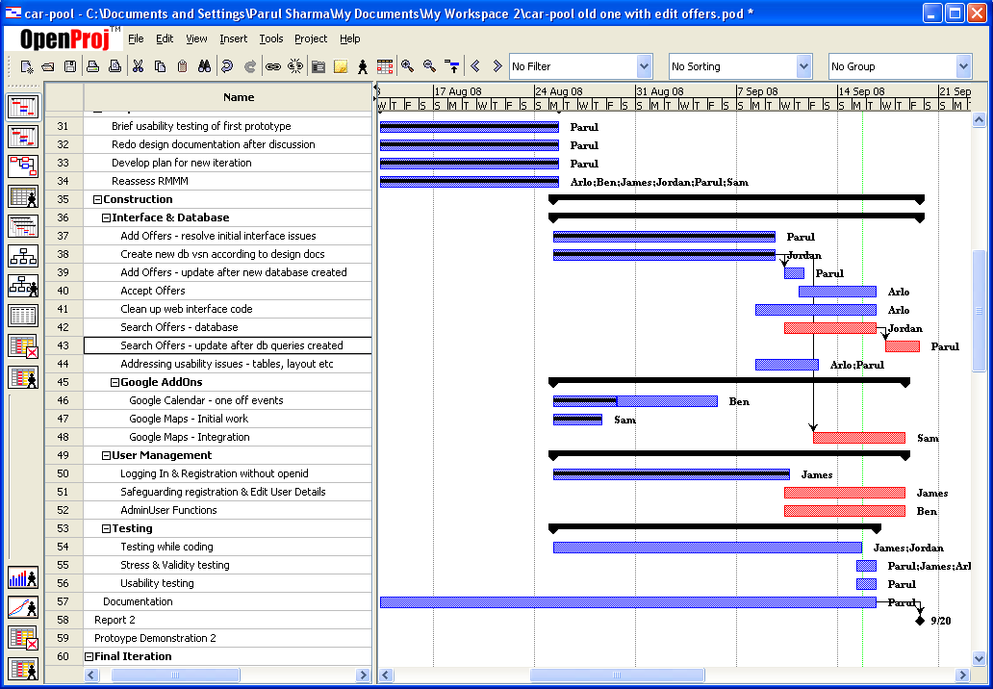Figure 2 : Gantt chart - Second iteration

The second iteration, displayed in Figure 2, focused on expanding the features that will be available through the system. A usability test of the first iteration prototype was done to get an overview of how well designed the system is for the user and the issues raised from it were added to our plan. In addition the first prototype design documentation and RMMM were revaluated in terms of redefining our scope. After some discussion it was decided that the scope of our project and design documentation should be modified as certain features were no longer needed. All the documentation was updated to reflect this change.

Figure 3: Gantt chart – Final iteration

The final iteration, as has been stated in the Scope for Prototype Three, is going to focus on adding in all the features that were postponed but are equally necessary for the project’s success.

4. Design Documentation

4.1 Domain Model

The domain model is modeled as a class diagram using Unified Modeling Language. It relates the objects that will be in our system’s domain to each other, and helps us identify attributes and methods of these objects.

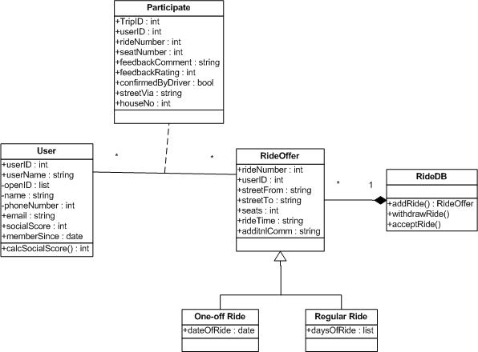

Figure 4: Class Diagram

Note that getters and setters have not been defined as operations for the diagram above. This is because they simply clutter up the diagram and in our opinion they are no more than visual noise.

4.2 Use Case Diagram

The use case diagram helps illustrate the functionality of a system visually in terms of the actors involved, what their goals are and it also helps us identify any dependencies between the use cases.

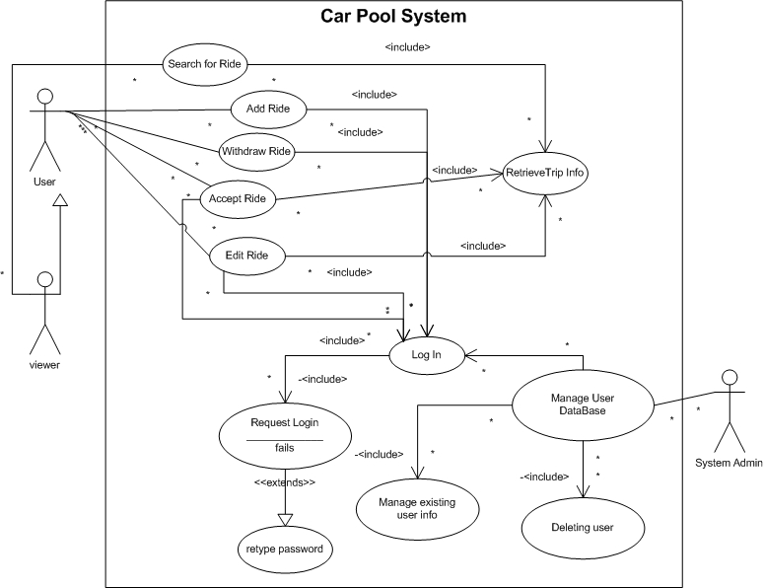

Figure 5: Use Case Diagram

4.3 Use Cases

The use cases describe the interaction between external actors and the system. They are the main frame of reference when constructing the system to ensure that the system does what it is expected to do. Just like the Use Case Diagram they are quite thorough and not just restricted to the current scope because it is good to have a broad vision of the system being built. These use cases are changed depending on how the customer’s requirements or our vision changes.

Use Case Name: | Registering on Car Pool site using OpenID
Actor: | User
Description: | The user should easily be able register on the site so they can start using it. They should be able to use their OpenID to do so.  The system should be able to verify the validity of their OpenID account and save the other details the user has entered.
Reference to requirements | (link to written requirements)
Pre-condition: | User wishes to be able to use the car pooling website.  The user has an OpenID account.
Typical Course of Events: | Actor:  Step 1. The user enters their OpenID username in the input box on the homepage as directed.  Step 5. The user can choose a username and click “check username availability” And the user can add details such as their email address and phone number. And finally click on “finish registration” | System:  Step 2. The system redirects the user to the OpenId site so they may log in to their account  Step 3. The OpenID site verifies the username and password.  Step 4. The system redirects user to site again and if the OpenID mentioned is not in system the user is taken to a Registration Form.  Step 6. The system now has a database instance created with user OpenID account, and username stored and system also issues a user id to uniquely identify the instance in the database. The rest of the details are added to the system database too. The system then displays the homepage with the user account box showing the user’s username and a Logout option beneath it.
Alternative Course A: | Step 4. The user tries again. | Step 3. The OpenID site tries to verify the user’s OpenID account. The username and password fail to match. The system displays a page to the user stating that their OpenID account was not validated. And asks them to try again.  Step 5. If this time it is successful then steps continue as per Typical Course of Events Step 4 otherwise it keeps repeating Alternative Course A till successful or users stops trying.
Alternative Course B: | Step 5. If on clicking Check Availability the User finds their username taken They choose another username and click “Check Availability” again. | Step 6. The system checks the database to see if any other user has the same username.  Step 7. If the name is being used by someone else the system tells the user they cannot have the username and must choose another one.  If username is available then events can continue as per Typical Course of Events Step 5 otherwise Alternative Course B repeats till success achieved or user stops trying.
Post-condition | The system now has the user’s details stored in the database  The user has successfully created an account with the system  The user is taken to the homepage where they can choose what to do next.
Assumption: | Usually the user doesn’t enter the wrong password for their Open ID account.  Usually the username chosen is available.

Use Case Name: | Registering on Car Pool site using username and password
Actor: | User
Description: | The user should easily be able register on the site so they can start using it. They should be able to sign up using a username and password  The system should be able to save the other details the user has entered to the account they just created.
Reference to requirements | (link to written requirements)
Pre-condition: | User wishes to be able to use the car pooling website.  The user wants to sign up to our site using a username and password
Typical Course of Events: | Actor:  Step 1. The user clicks the Register link  Step 3. The user can choose a username and click “check username availability” And the user can add details such as their password, email address and phone number. And finally click on “finish registration” | System:  Step 2. The system directs the user to the registration page.  Step 6. The system now has a database instance created with user username & password stored and system also issues a user id which is also stored in the database. The rest of the details are added to the system database too. The system then displays the homepage with the user account box showing their username and a Logout option beneath it.
Alternative Course A: | Step 3. If on clicking Check Availability the User finds their username taken They choose another username and click “Check Availability” again | Step 4. The system checks the database to see if any other user has the same username. If the name is being used by someone else the system tells they cannot have the username and must choose another on.  Step 5. If username is available then can continue as per Typical Course of Events Step 3 else repeat Alt Course A till successful.
Post-condition | The system now has the user’s details stored in the database  The user has successfully created an account with the system  The user is taken to the homepage where they can choose to do what they want.
Assumption: | Usually the username chosen is available.

Use Case Name: | Edit User Details
Actor: | User
Description: | The user should easily be able to change any details they would like to.
Reference to requirements | (link to written requirements)
Pre-condition: | The user has account on the system.  The user is logged into that account.  The user wishes to change some details of his/her account (e.g. email)
Typical Course of Events: | Actor:  Step 1. The user clicks on the link that takes them to their account page.  Step 3. The user changes the detail they want to. They are only able to change their: email address, phone. The user clicks the Save Changes button. | System:  Step 2. The system takes the user to their account page.  Step 4. The system saves the changed details appropriately in the database and on the other required pages.  Step 5. The system shows user a “your details have been successfully changed” message.
Post-condition | The system now has the user’s changed details stored in the database  The user has successfully changed the details they wanted to  The user informed of their success.
Assumption:

Use Case Name: | Add an Offer
Actor: | User
Description: | The user should easily be able to add an offer for a Ride and the system should store the details of this offer as the user has entered them.
Reference to requirements | (link to written requirements)
Pre-condition: | The user has an account with the site.  The user is logged into that account.  The user wants to offer a ride from a certain location to another location on a certain date/certain days.
Typical Course of Events: | Actor:  Step 1. The user clicks on the Add Offer button  Step 3. The user enters the following details:  a. Ride From Street  Ride To Street  (the only regions available are Palmerston North due to the scope of this project)  b. The user then encounters the option between One-off and Regular and chooses one. There is no default option so the user is forced to make a decision.  c. The user then can add information regarding departure time and approximate length of trip in minutes  d. The next field the user fills is of the number of seats available.  e. The user chooses if they want to receive emails if someone comments on the offer or accepts it.  f. The user finally clicks the Add Offer button. | System:  Step 2. The system takes the user to the Offer Form  Step 4. The system generates a Ride Id and then saves the Offer details associated with it.  Step 6. The system adds the ride to the user’s Google calendar. The system takes the user to a page announcing the Ride has been successfully offered.
Alternative Course A: | Step 3b. The user chooses Regular ride option  Step 5. User chooses the appropriate days and the rest continues from step 3c in Typical Course of Events. | Step 4. System displays the Days of Ride field where user can enter the days they will be traveling.
Alternative Course B: | Step 3b. The user chooses One off ride option  Step 5. User enters the appropriate date and the rest continues from step 3c in Typical Course of Events. | Step 4. System displays the Date of Ride field where user can enter the date they will be traveling.
Post-condition | The system now has the offer details stored in the database  The user has successfully created an offer. This offer can be accessed from the User’s Account where the user may edit details and withdraw offer as long as no one has signed up to it.  The user is taken to a page informing them the request has been successfully added.
Assumption:

Use Case Name: | Accept an Offer
Actor: | User
Description: | The user should easily be able to accept an offer.
Reference to requirements | (link to written requirements)
Pre-condition: | The user has an account with the site.  The user is logged into that account.  The user has searched for rides and found a ride offer they would like to accept.  The user has, if they wanted to, discussed in the comments of that ride page whatever they need to with the person offering the ride.  The user is on that Ride’s page.
Typical Course of Events: | Actor:  Step 1. The user clicks on the link that leads to the relevant Ride Page.  Step 3: The user specifies what street they would like to be picked up from.  Step 4. The user clicks the accept offer button. | System:  Step 2. The system takes the user to the Ride page.  Step 5. The system sends the person who offered the Ride a message through their account page asking if they agree to pick the user up at the location they have specified. That user clicks confirm.  Step 6. The system sends the user who accepted the ride a message through their account page informing them of the confirmation and the user can now click Add Ride as Event to Google Calendar.
Alternative Course A: | Step 5. The user who offered ride clicks on the Decline Acceptance button. | Step 5. The system informs the person who accepted the ride that the driver will not be able to pick them up from their preferred location and their acceptance was declined.
Post-condition | The user has Accepted the Offer. If they accepted and the driver has accepted their Acceptance then this offer can be accessed from the User’s Account where the user may be able to withdraw from the ride. The number of seats available is reduced and the ride is added as an event to the user’s calendar.
Assumption:

Use Case Name: | Edit Offer
Actor: | User
Description: | The user should easily be able to change any details they would like to on their offer
Reference to requirements | (link to written requirements)
Pre-condition: | The user has account on the system.  The user is logged into that account.  The user has made an offer for a ride.  That offer has not been accepted by anyone yet.  The user wishes to change some details of that ride.  The user is on their Account page which lists their requests and offers.
Typical Course of Events: | Actor:  Step 1. The user clicks on the Edit button beside the appropriate ride offer.  Step 3. The user changes the details they want to. The user clicks the Save Changes button. | System:  Step 2. The system takes the user to the Edit Offer page.  Step 4. The system saves the changed details appropriately in the database, Google calendar and on the other required pages. The system takes user to a “your offer details have been successfully changed” page.
Alternative Course A: | Step 3. The user clicks Don’t Save Changes. | Step 2. The system takes the user to a page that informs them their changes were not saved.
Post-condition | The system now has the user’s changed details stored in the database  The user has successfully changed the details they wanted to  The user is taken to a page informing them of this success.
Assumption: | The user will only be able to Edit as long as no one else has accepted the ride

Use Case Name: | Withdraw Offer
Actor: | User
Description: | The user should easily be able withdraw their offer
Reference to requirements | (link to written requirements)
Pre-condition: | The user has account on the system.  The user is logged into that account.  The user has made an offer for a ride  This offer has not been accepted by anyone else  The user wishes withdraw the offer.  The user is on their Account page which lists their requests and offers.
Typical Course of Events: | Actor:  Step 1. The user clicks on Withdraw button beside the appropriate ride.  Step 3. The user clicks Yes. | System:  Step 2. The system takes the user to “I really want to delete this offer” page.  Step 4. The system deletes offer details from the database and other pages such as Google Calendar and displays “offer has been deleted” page to the user.
Alternative Course A: | Step 3. The user clicks No. | Step 2. The system takes the user to “offer has not been deleted” page.
Post-condition | The system now has deleted the offer from database and user’s accounts.  The user is taken to a page informing them of this.
Assumption: | The user will often go ahead with the deletion.  The user will only be able to as long as no one else has accepted the offer

5. Risk Mitigation Monitoring and Management Plan (RMMM)

The following RMMM was developed in consultation with our team. Mitigation and Monitoring measures have been taken to avoid and keep track of the risks listed and if we do encounter a problem eventually we will be able to employ our Management strategy to deal with it.

Feature Priority Order: this has been established based on what requirements our customers (the lecturers) have explicitly stated in the written outline provided to us a well as discussion between the members of what is required for the success of our project. The Feature Priority Order is defined to give an idea of what features to cut back on if the project’s progress is lagging behind and the scope of the system needs to be reduced.

Registration & Logging In of users: Open ID
Add One off Offers
Google calendar: one off event

See all available offers
Accept offers: can specify via which location to be picked
Registration of users: username and password
Google maps
Search for rides
Accept acceptance from account page
Edit ride details from account page
Accept offers: can specify number of seats you want
A social scoring system
Safeguarding registration
Send automated email notifications
Add Regular Offers
Google calendar: regular event
Add Requests
Add Counter Offers to Requests
RSS feed
Abstraction of Calendars

6. Software Quality Assurance (SQA)

It is important to ensure the quality of the software that is being built and SQA activities can help us do this by ensuring we do not have a lack of conformance to the requirements, explicit or implicit. To this end we plan on implementing the following quality control activities:

6.1 Unit testing

This is important to ensure that individual units in our source code are functioning as expected. We have continued to expand our JUnit test cases for all the database and user management functions we create. They help us gain an understanding of why a certain feature is failing as we can narrow the problem down to a particular failed test case.

Figure 6: JUnit Tests

6.2 Usability Testing

We will ask various people to beta test our website to identify any areas that users could potentially have issues with. This will be done just prior to starting on prototype two and just after finishing prototype two. Changes will be made to the website depending on what the users recommend will make it easier for them to interact with the website.

Results from Usability Testing of Prototype One:

Technical Response:

None of the users knew what Open ID was. This would not be an issue if they could also register on our site with a username and password because then they would be able to choose that option instead. However since this was the first prototype they could only register using open id. For the purposes of testing we created an Open ID account for them and gave them the password and asked them to use that for the registration form.

Some users appreciated how after clicking Confirm Registration they were logged into the site directly and redirected to the home page instead of waiting for a validation email to first confirm their registration. While this is nice we do eventually need a way of safeguarding registration and the most common way is to send validation emails. Perhaps we can use another means to safeguarding registration such as making users answer questions like “what day comes after Tuesday” or “am I likely to play tennis if it is raining outside?” to confirm that a person and not a machine is registering.

When users clicked on Update Details button on Edit Details page and nothing happened they were confused. We then explained that that functionality had not been implemented yet.

In the Location To and From text boxes in Find A Ride we noticed that the location names added were not consistent. Some would say “Palmy” to “Welly” others PN to NP etc. It has been decided that standardizing the locations to avoid variations is necessary so perhaps a combo box will be more suited to the task.

In the Date field the users had trouble entering the date in yyyy/mm/dd format. It is not very intuitive. However we already had plans of changing this for the next iteration to dd/mm/yyyy format.

In Find a Ride page we had to explain to the users about how clicking the name of the From location would Add the Ride to the user’s account. Of course this was not obvious at all and will be changed. It was explained to the user that eventually there will be a link called Accept Ride that can be clicked. The users appreciated the fact that when they did accept a ride the page reduced the number of seats available for that ride.

Emotional Response:

Some users felt that some explanation of the aim of the site and how to use it should be given on the home page.

Most felt the background needs to be more inviting - a different colour than white would be preferred though they found the structure elegant and neat.

On the right menu a user said it would be better to have the username instead of open id displayed which they felt was too long

The users said Find A Ride table is not spaced out well enough and looks clustered.

In terms of page structures all users felt that the site was clear and intuitive.

6.3 Compatibility Testing

The following is a list of Operating Systems (OS) and web browsers that our website appears and functions correctly in. This list will be expanded to ensure our application has maximum compatibility with the majority of environments it will be accessed from.

Browsers>  OS  V | Internet Explorer | Firefox
Windows XP | OK | OK
Linux | Haven’t tried | OK
Ubuntu | Haven’t tried | OK

6.4 Integration Testing

Successful integration of all components is an essential part of our project. We followed a Bottom Up approach by first testing that our web interface worked with the user authentication and Google modules and finally that all this worked successfully with our database. In the next iteration we continued this approach by ensuring we first integrated each new feature in the database with the web interface and that it worked before moving on to new features.

6.5 Process Monitoring

This helped us ensure that the steps we took to carry out a process were actually those that we intended to take as stated in our documentation. By ensuring that we adhered to our project methodology we ensured that we are on track with process conformance. We did this through weekly meetings and questioning each process and requirement change in terms of the project aim.

6.6 JDepend
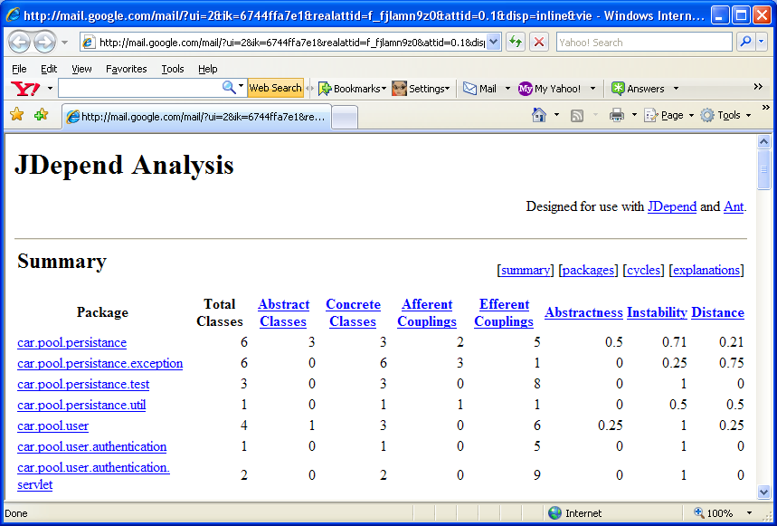
JDepend analysis will helps us measure the quality of our design in terms of how extensible, reusable and maintainable it is with regards to managing package dependencies.

Figure 7: JDepend Analysis

Changes from first iteration:

The scope of the project was revised:
Return trip and requests were no longer available features.
The background of the site has been changed according to user feedback
The design documentation
Via locations added by rider instead of driver

Abilities vs Tasks

The following is a list of the tasks our members have been assigned and what skills they have that will be employed for the completion of those tasks.

